**SMART STAR EXAMINATIONS BOARD**

**END OF TERM I EXAMINATIONS - 2024**



**LITERACY 1A**

**PRIMARY TWO**

***Time Allowed: 2*** *hours* ***15*** *minutes*

**Name...........................................................Stream............**

**INSTRUCTIONS**

1. ***Avoid unnecessary crossing of work.***
2. ***Use very good handwriting.***

**SECTION A**

1. Name the body organ used for seeing.

_________________________________________________

1. Underline one common disease spread by a mosquito.

**Trachoma, measles, malaria, cholera**

1. 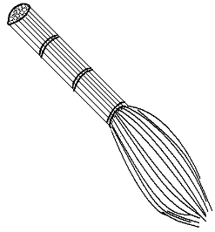Write the use of the item below.

_____________________________

1. State one reason why people do physical body exercises.

__________________________________________________

1. How many eyes do you have**?**

__________________________________ eyes

1. Write down one place where we get food.

_________________________________________________

1. **Name the dangerous object below.**

**___________________________**

1. What is personal hygiene**?**

__________________________________________________

1. Name the best weather for flying kites.

_____________________________ weather

1. **Tick one place where sick people go for treatment.**

hospital, market, bank

1. Which childhood immunisable disease makes the child lame**?**

___________________________________________________

1. 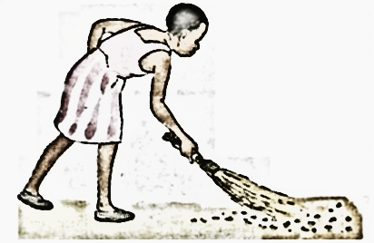**Name the health activity below.**

__________________________

1. Give one product we get from the animal below.

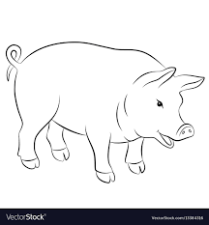

_______________________

1. Mention one example of garden tools.

__________________________________________________

1. How do we keep our classrooms clean**?**

_________________________________________________

1. In the space given, draw a child suffering from measles.

|  |
| --- |
|  |

1. Write down one product we get from birds.

_________________________________________________

1. Suggest one way of caring for your hair.

_________________________________________________

1. Which animal guards our homes**?**

_________________________________________________

1. Fill in the missing letters correctly.

kn__f___

**SECTION B**

1. a) Name these common food we eat.

|  |  |  |
| --- | --- | --- |
| **MAD** | Related image | https://encrypted-tbn1.gstatic.com/images?q=tbn:ANd9GcRymXgh06j7z_yDqY0kkQ7qlxWwtBlDRDLzumpGUIWWkOLY6mvC |
|  |  |  |

b) Write one reason why people eat food.

_________________________________________________

1. a) What are living things**?**

**_________________________________________________**

_________________________________________________

b) Use **true** or **false** to complete the sentences.

i) A stone is a living thing _______________________

ii) All living things move _________________________

1. **Match animals to their young ones.**

cow cub

dog duckling

lion puppy

duck calf

1. **a) Name these things we find in the First Aid box.**

|  |  |
| --- | --- |
|  | D:\HORMISS\PHINEHAS\PASTOR SENGOBA GW\PASTOR\Typist Diagrams\General\glove.jpegD:\HORMISS\PHINEHAS\PASTOR SENGOBA GW\PASTOR\Typist Diagrams\General\glove.jpeg |
|  |  |

1. Why do we give First Aid**?**

_________________________________________________

1. a) **Name the parts of the head**.



**A**

**B**

**D**

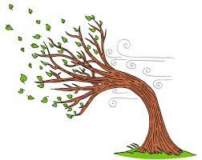

**C**

A ______________________

C ______________________

D _______________________

b) How useful is part marked **B**

_________________________________________________

1. a) Mention any two things we use to clean the body.
2. ______________________________________________
3. ______________________________________________

b) Why do we wash our hands after visiting the toilet**?**

_______________________________________________

c) How many body senses do you have**?**

**_____________________________________________**

1. **a) Name these types weather.**

|  |  |
| --- | --- |
|  |  |
|  |  |

b) Give one item we use on a rainy day.

_________________________________________________

1. **Name the body exercises below.**



**A**

__________________________

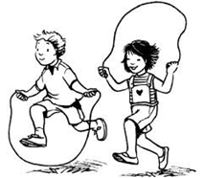

**B**

_________________________

b) Which item is used in body exercise (**B**)**?**

**_______________________________________________**

1. Write down two products we get from animal skins.
2. ___________________________________________
3. ____________________________________________

**END**